**Our plan -**

1. Web application from satellite image to count trees using **DNN-** **Inception Algorithm** vertically and horizontal and providing the real time information about a specific area like - number of trees, tree vs man ratio, ranking of the city/area in the whole town or state.
2. People in a specific location taking picture of garbage heap or patch and upload it to the map to request the nearby for cleanup.
3. Sending notification during weekend to cleanup garbage heap near user.

**What we have done so far-**

1. We made a web page showing the feature we are going to provide

Link: <https://github.com/CS-Ponkoj/Gray-To-Green>

1. Connected map in the webpage to visualize how the feature will be working

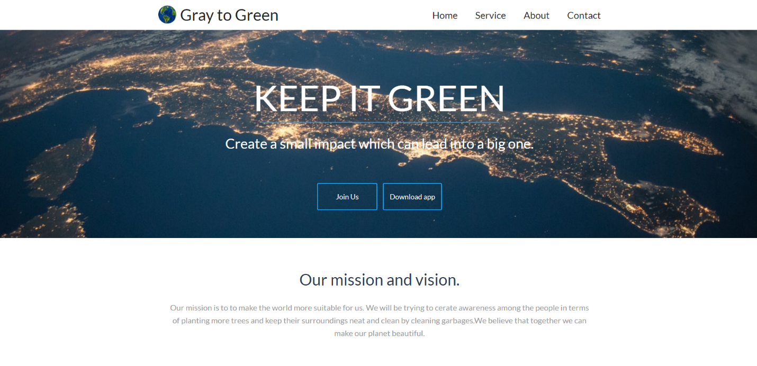

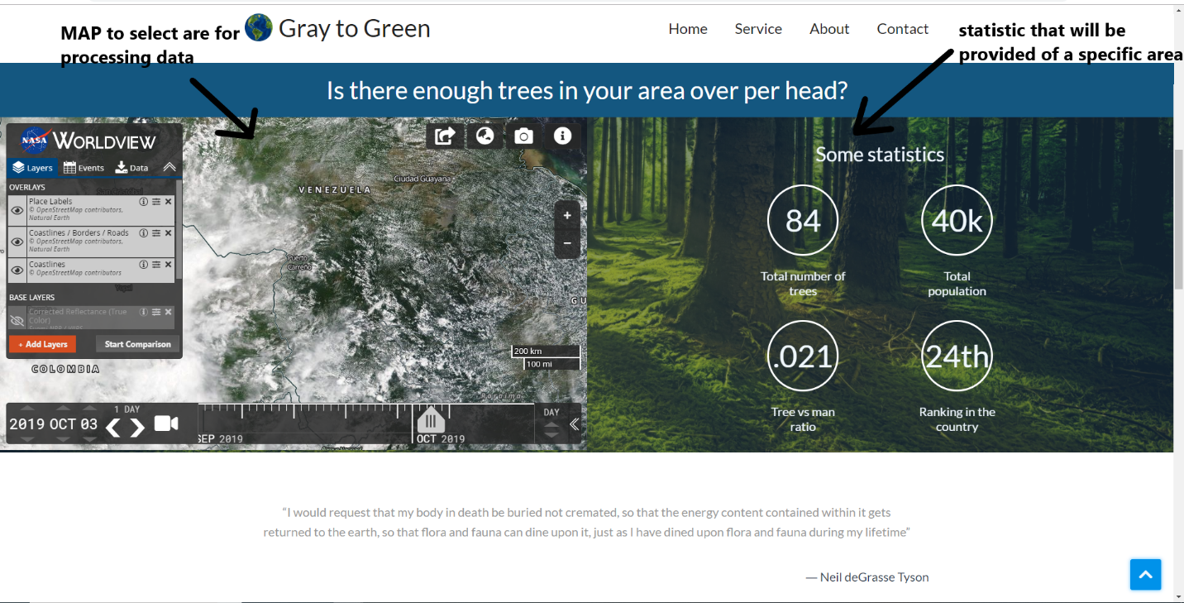

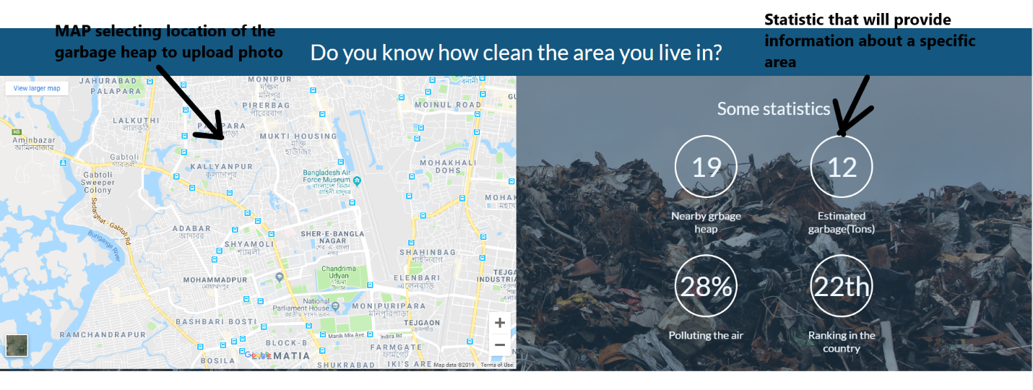

1. Connected API to surprise our user to give the awesome experience of APOD using NASA’s API.



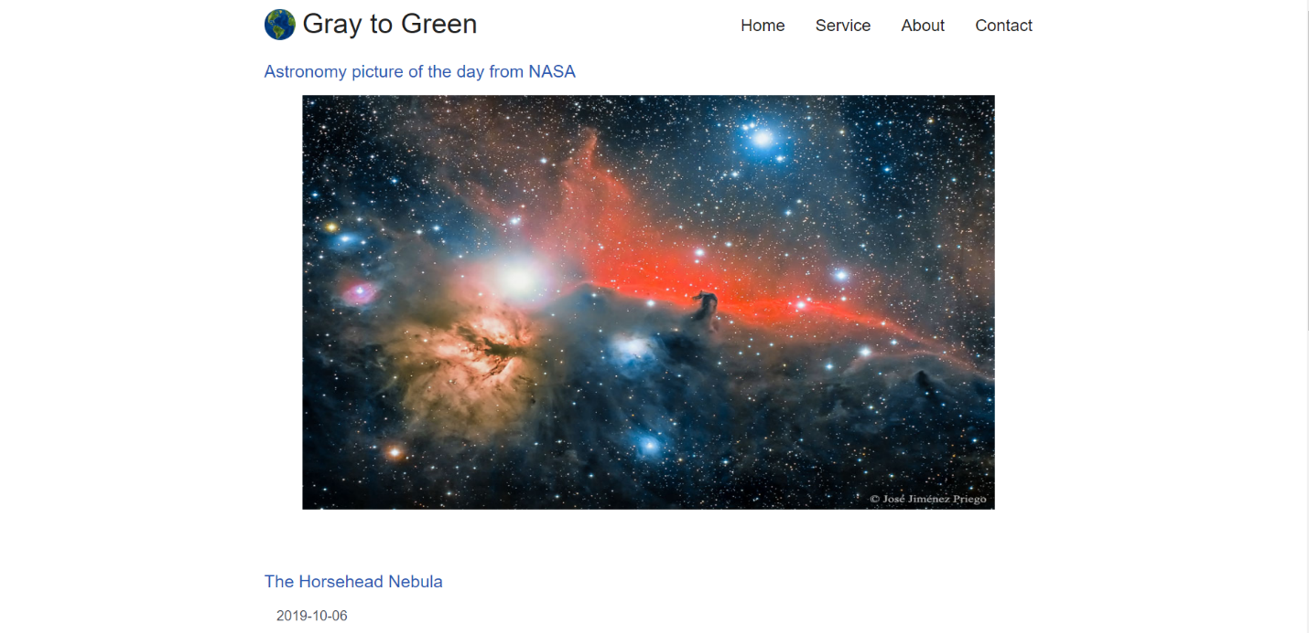

1. Contacts for sending notification.

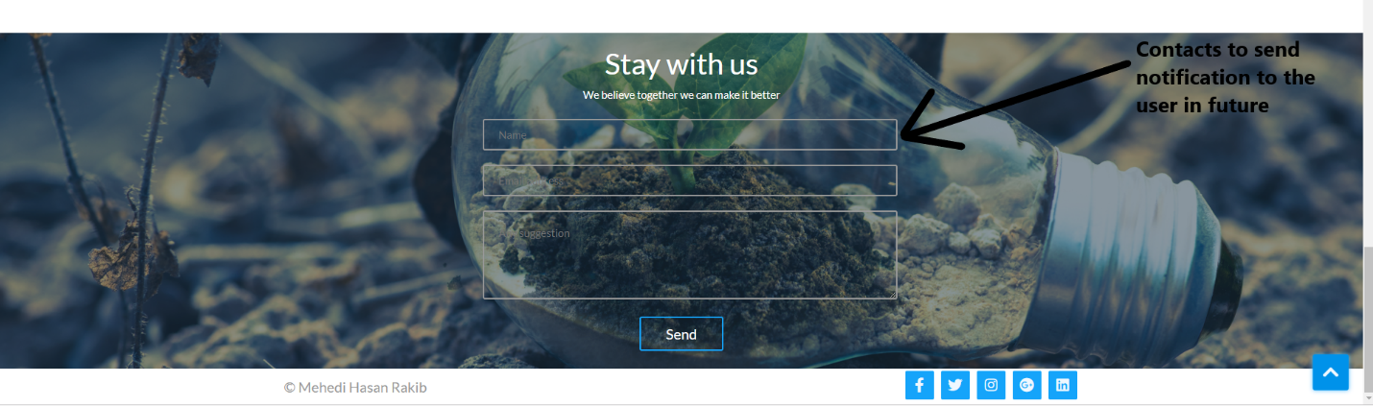

**What we are working on -**

We created a prototype showing how it will work and we are working on it they are-

Showing how the algorithm is working as it takes time to set up the algorithm.